Inserting a Chart Link into a Document

- Save this document into your G: drive and copy budget.xls into the same folder on your G: drive. Open the copy of budget.xls you just saved.
- 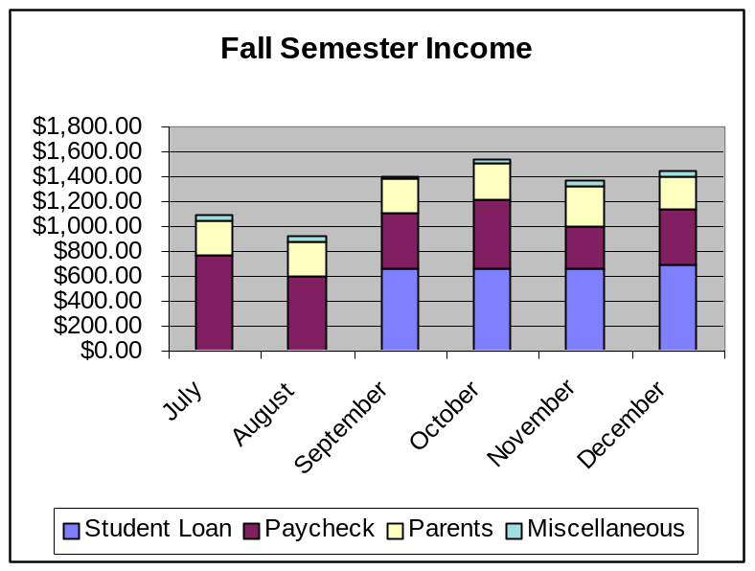Go to the Income sheet. Using the fall semester data, build a stacked column chart. Paste your chart as an object on the Income sheet. Your finished chart should look like this:
- Select your chart, open the Edit menu, and choose Copy.
- Position the insertion point at the end of this document. Open the Edit menu and choose Paste Special. In the dialog box which opens, choose Paste Link.
- In the spreadsheet, change the amount of the student loan in July from $0.00 to $1,000.00. The chart within the spreadsheet should change as well as the chart in the Word document. Call me over if one or both don’t change.
Insert your chart here:

